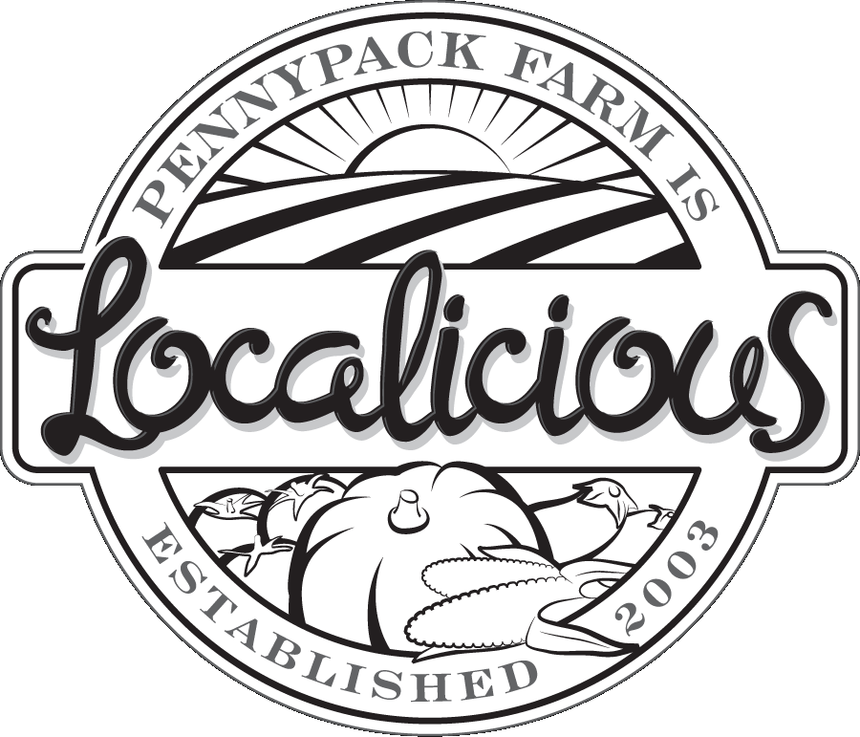Pennypack Farm – Localicious Silent Auction

Schedule
ASAP, by August 23 – Letter mailed/hand delivered /Initial contact
Pick up or receive items in mail – arrange to drop at farm or with Heather.
August 23-Sept. 8 – Follow up phone calls
Sept. 15 – Items received
Sept. 27 – Localicious Event

Items Tracked by Debbie: PennypackFarm.Auction@gmail.com
Large list of people to renew, but we are always looking for new businesses!

Best Bets and Ideas:
Places where you go a lot – favorite neighborhood restaurants, services you use, stores you visit.
Local businesses – big chain store managers often don’t have the authority to make donations.
Friends/neighbors who have a business

Restaurants/Food – all types: restaurants, wine, chocolate, etc. (gift certificate/goodies for a basket)
Services – salons, florists, dry cleaners, mechanics, etc. (gift certificate for service)
Entertainment/Cultural orgs/Unique experiences – mini golf/bowling, concerts, theaters, museums, memberships of other non-profits, classes, sports tickets, hot air balloons, fun stuff
Health – Yoga, gym, massages, etc.
Hand-crafts/artwork, etc.
Travel – vacation homes down the shore, cabins in the Poconos, time shares in warm places
Outdoor – Gardening/Farm/Athletic stuff

How to solicit in person: Go at a not super-busy time. Take materials: Letter, Brochure, Form. Look around with interest (always great if you can buy something!). Ask to speak with owner/manager.
Sample Script:
- Hi, I’m ________. I live here/come here often/really enjoy ___________ about your business.
- I’m on the auction committee for Pennypack Farm & Education Center’s annual fundraiser.
- PFEC is a local, organic farm that offers a CSA, educational programs for kids, and donates to local food banks. Our mission is all about local, sustainable food.
- (Give them a brochure with form.)
- We’re hosting our annual Localicious event in September. We will have over 200 people at the event, and this is a great way to advertise.
- Would you donate an item or gift certificate for our auction?
- (If you have a specific item in mind, ask for it!) Or: Buy an ad or sponsor the event.
- WAIT. After you have asked the question, don’t be the first to speak!!

Concerns
- “I can’t donate much.” – That’s ok! We will combine your gift certificate with other items to make a bundle (i.e. Date Night: restaurant gift certificate, florist gift cert, dry cleaning gift cert)
- Logistics – we can pick up items if they need, or create a gift certificate if they don’t have one.

Promotion of Donations
E-newsletter to members/Web preview
Event Program listing
Display at auction
Nitty Gritty/Tracking Items
Donor needs to fill out donation form: item, value, signature
They will receive a tax letter for their files

